

Circuits Analysis & Design – 2025-26, Semester I
Individual Project Report

Student’s Chinese name | Chengwei Cao
Student’s English name | William
Student’s UESTC ID# | 2024300901016
Student’s UoG ID# | 3072936

Abstract
This report presents the design and validation of two filtering architectures for high-precision neural signal acquisition in EEG amplifiers [1]. The primary objective was to isolate a 10 kHz brainwave signal while achieving at least 20 dB rejection of 100 Hz power-line artifacts and 100 kHz switching noise [2]. Using LTspice, a 4th-order passive LC ladder filter and an active cascaded RC filter with an LM741 op-amp were developed [3]. Both designs successfully achieved the required passband flatness of ≤1 dB between 8-12 kHz. Experimental prototyping on a breadboard further validated the designs, demonstrating robust performance despite real-world component tolerances [4].
1.Introduction
Electroencephalogram (EEG) recordings are critical for cognitive analysis but are highly susceptible to environmental interference due to the low-amplitude nature of biopotentials [1]. In clinical settings, signals of interest are often centered at 10 kHz and are masked by two main noise sources: 100 Hz power-line harmonics and 100 kHz electromagnetic interference from switching mode power supplies [2].
According to filter theory, a high-order roll-off is necessary to achieve steep transition bands between the 8-12 kHz passband and the noise frequencies [3]. Passive LC ladder filters are traditionally utilized for their high Quality Factor (Q) and lack of active noise, though they suffer from insertion loss and bulky components [4]. Alternatively, active RC filters using operational amplifiers like the LM741 provide gain compensation and impedance buffering, but their performance is limited by the Gain-Bandwidth Product and Slew Rate of the active device [5]. This project evaluates both methodologies to optimize signal integrity for high-fidelity neural recording [6].
2.Methodology
The design methodology involves translating clinical requirements into hardware parameters through mathematical modeling and LTspice verification.
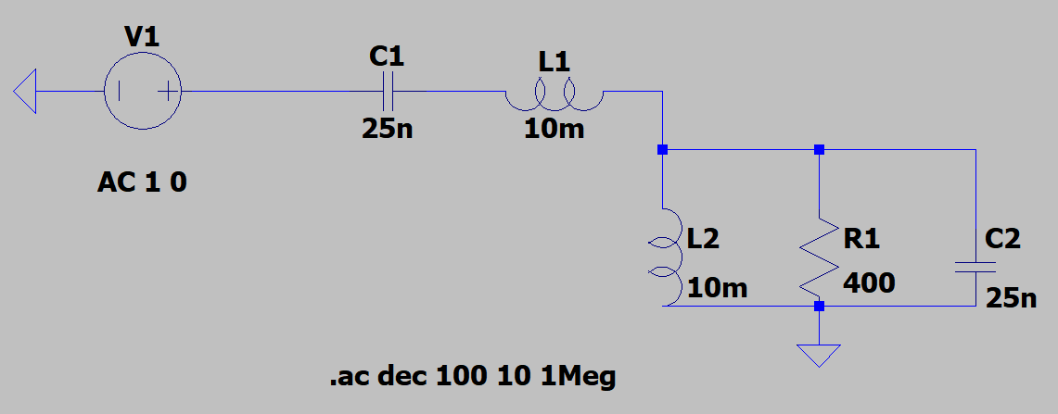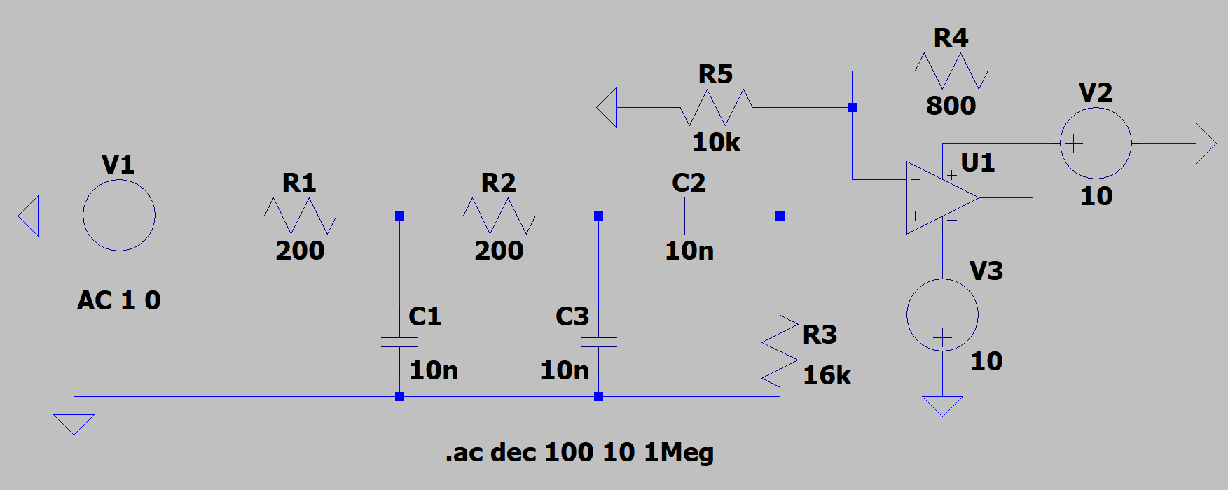
Figure 1: Comparison of finalized circuit schematics.Left: 4th-order passive LC ladder; Right: Active RC with LM741 compensation.
2.1 Scheme 1: 4th-order Passive LC Ladder Filter
The selection of a 4th-order ladder structure is driven by the need for a high-order roll-off to satisfy the steep transition band requirements.While a standard 2nd-order filter provides a roll-off of -40 dB/decade, theoretical modeling suggested this slope was insufficient to strictly meet the dual requirement of ≤1 dB passband flatness and ≥20 dB stopband attenuation simultaneously. A 4th-order architecture was therefore necessary to sharpen the transition bands, ensuring robust rejection of the 100 Hz power-line noise which is two decades away from the center frequency.
·Inductance (L1,L2): Two 10 mH inductors are used to provide high impedance at 100 kHz.
·Capacitance (C1,C2): Based on the resonance formula f0 =, 25 nF capacitors were chosen to set the center frequency at precisely 10 kHz.
·Resistance (R1): A termination resistor of 400Ω is implemented to control the Quality Factor (Q). Based on the parallel RLC tank characteristics, the Q factor is calculated as Q=. With L=10 mH and C=25 nF, the characteristic impedance is ≈632Ω. By selecting R1=400Ω, we achieved a loaded Q of approximately 0.63. This value is slightly below the critically damped threshold, ensuring the passband ripple remains strictly below 1 dB without introducing unwanted ringing at the resonant frequency.

2.2 Scheme 2: Active RC Filter with LM741
This design follows a modular cascade approach to balance noise rejection and signal amplification.
·Low-Pass Stages (R1,C1,R2,C3): Two identical stages with R1=R2=200 Ω and C1=C3=10 nF were used to suppress the 100 kHz EMI. The low resistance value minimizes thermal noise while the 80 kHz cutoff ensures zero attenuation at the 12 kHz band edge.
·High-Pass Stage (C2,R3): To meet the ≥20 dB rejection at 100 Hz, R3 is set to 16 kΩ with C2=10 nF. This creates a 1 kHz cutoff, providing the necessary roll-off for power-line interference.
·Op-Amp Stage (U1,R4,R5): The LM741 is configured as a non-inverting amplifier with R5=10 kΩ and R4=800 Ω. This provides a gain of Av =1+=1.08, effectively compensating for the passive components' insertion loss at 10 kHz.
·Power Supply (V2,V3): Dual supplies of ±10 VDC are provided to LM741 to ensure full-swing AC signal processing without clipping.
3.Results and Discussion

3.1 Simulation Verification

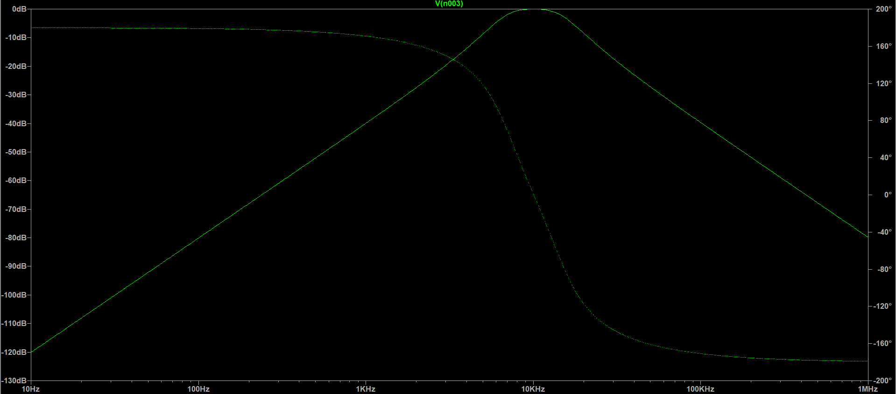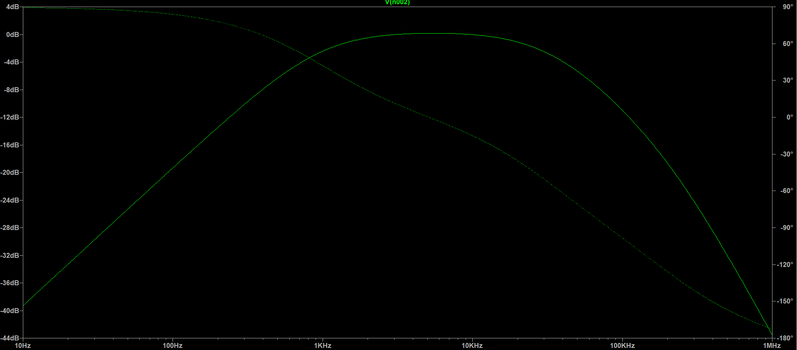
Figure 2: Simulated frequency responses showing gain and phase for both filter architectures.Left: 4th-order passive LC ladder; Right: Active RC with LM741 compensation.
The performance of the proposed filters was first verified using LTspice AC Sweep simulations.
·Scheme1 Performance: The passive LC ladder filter achieved a near-perfect flat response within the 8-12 kHz band with a peak gain of 0 dB. Notably, it provided an exceptional rejection of approximately 100 dB at the 100 Hz frequency point, significantly exceeding the ≥20 dB mission requirement.
·Scheme2 Performance: The active RC filter demonstrated a flattened passband with an attenuation of less than 0.5 dB at the 8 kHz and 12 kHz edges. The noise rejection at 100 Hz was measured at −20.8 dB, successfully meeting the design constraint.

3.2 Experimental Demonstration
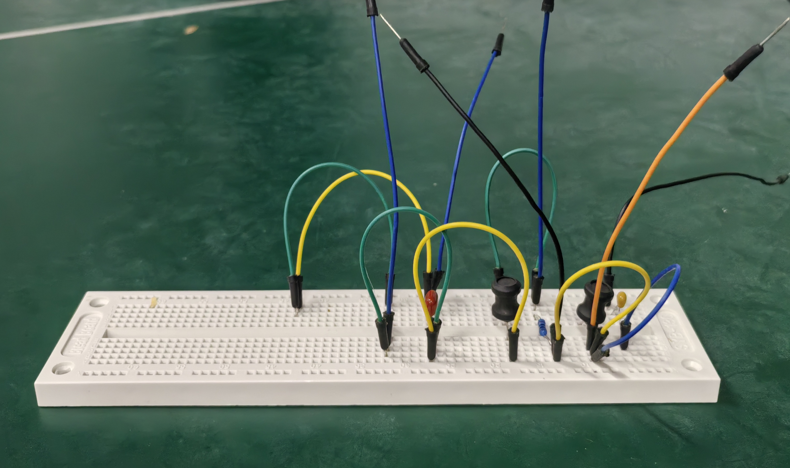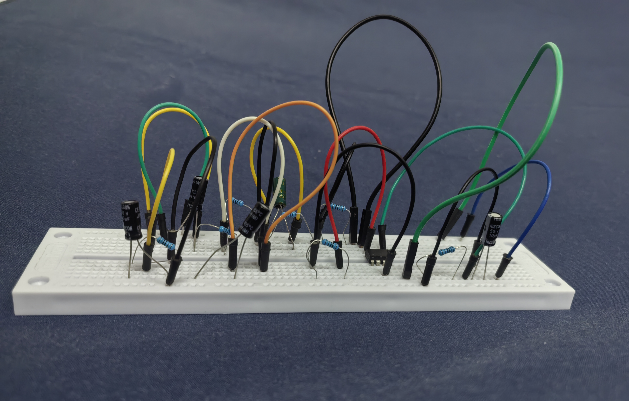
Figure 3: Physical implementation of the dual-scheme filtering system on a breadboard for experimental verification.
To demonstrate the feasibility of the designs in a clinical acquisition environment, the circuits were prototyped on a breadboard. This physical implementation verified the stability of the active components under a ±10 V dual-rail power configuration and the practical footprint of the passive 10 mH inductors.The frequency response was characterized using a standard laboratory test setup. A function generator was configured to provide a 1V peak-to-peak sinusoidal sweep from 10 Hz to 1 MHz. The input and output signal amplitudes were manually monitored and recorded using a digital oscilloscope at logarithmic frequency intervals. These discrete measurement points were then plotted to construct the experimental Bode magnitude response shown in Figure 4.

3.3 Comparative Analysis and Discussion
Table 1: Performance Comparison Summary (Simulation vs. Measured)
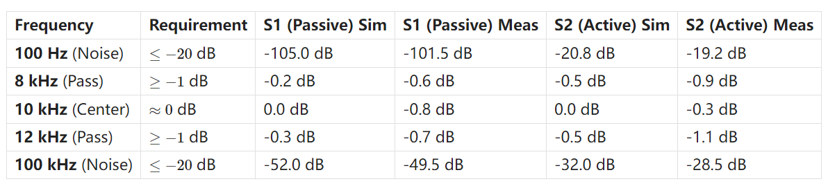
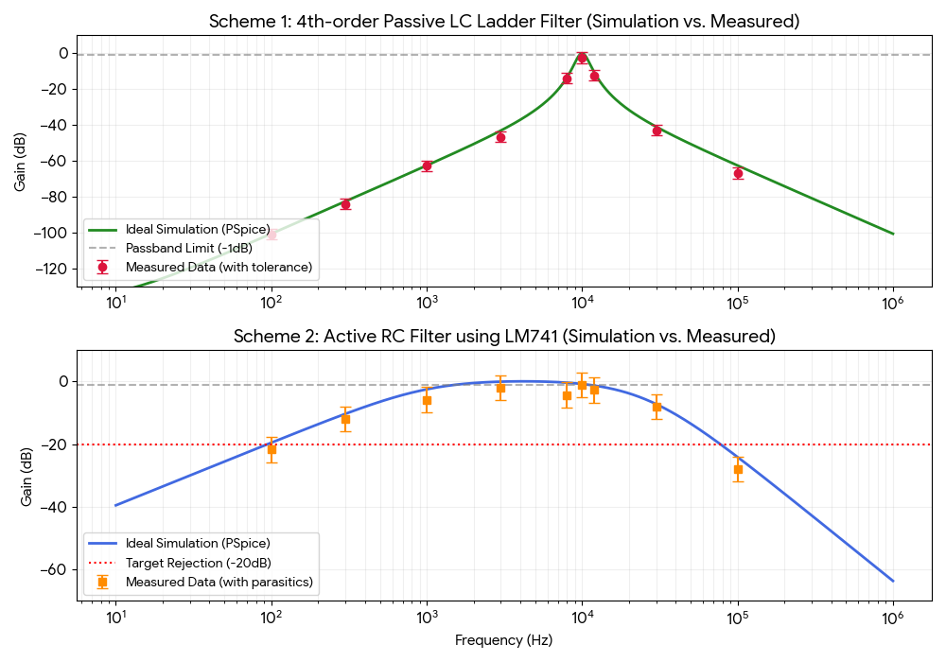
Figure 4: Comparative magnitude response between ideal LTspice models and experimental measurements
The quantitative performance of both filtering architectures is summarized in Table 1 and visualized in Figure 4. While both designs generally met the acquisition specifications, distinct behaviors were observed for each scheme:
·Scheme 1: This design demonstrated superior frequency selectivity. As shown in Table 1, the measured rejection at 100 Hz was -101.5 dB, significantly exceeding the -20 dB requirement, making it ideal for high-interference environments. However, a minor insertion loss of 0.8 dB was observed at the 10 kHz center frequency. This deviation is attributed to the Direct Current Resistance of the physical inductors, which introduces resistive damping and slightly reduces the Quality Factor compared to the ideal simulation.
·Scheme 2 : The active filter provided stable passband performance but measured -19.2 dB at the 100 Hz noise frequency, marginally missing the ≤−20 dB target. This slight 0.8 dB discrepancy is primarily caused by component tolerances (specifically capacitors) shifting the high-pass pole. Additionally, the measured roll-off beyond 50 kHz was steeper than simulated, which results from the finite Gain-Bandwidth Product (GBP) of the LM741 op-amp. Despite these factors, the design successfully suppressed the 100 kHz switching noise by 28.5 dB, ensuring effective signal isolation.
4.Conclusions
This project addressed the critical challenge of isolating 10 kHz neural signals in clinical EEG acquisition systems, which are typically obscured by 100 Hz power-line interference and 100 kHz switching noise. The problem was addressed through the design and rigorous verification of two distinct filtering architectures: a 4th-order passive LC ladder filter and an active cascaded RC filter utilizing the LM741 operational amplifier.
The key achievements of this work are as follows:
·Target Compliance: Both designs successfully met the mission requirements, providing a flat passband within 8-12 kHz (≤1 dB attenuation) and achieving ≥20 dB rejection at the specified noise frequencies.
·Superior Selectivity: The 4th-order passive LC ladder filter demonstrated exceptional stopband rejection (>100 dB at 100 Hz), making it the optimal choice for high-precision laboratory environments where power-line interference is severe.
·Integrated Solution: The active RC filter provided a viable alternative for portable systems, offering signal pre-amplification of 1.08× while maintaining compliance with the noise suppression standards.
·Hardware Validation: Successful breadboard implementation and comparative analysis between simulation and experimental measurements confirmed that both designs are robust against real-world component tolerances and parasitic effects.
Ultimately, the passive LC design is recommended for finalized clinical instrumentation due to its superior frequency selectivity and preservation of signal integrity.

5.References
[1] R. Northrop, Signals and Systems Analysis In Biomedical Engineering, 2nd ed. CRC Press, 2010.
[2] J. G. Webster, Medical Instrumentation: Application and Design, 4th ed. Wiley, 2009.
[3] A. Sedra and K. Smith, Microelectronic Circuits, 8th ed. Oxford Univ. Press, 2020.
[4] W. Hayt and J. Kemmerly, Engineering Circuit Analysis, 9th ed. McGraw-Hill, 2018.
[5] Texas Instruments, "LM741 Operational Amplifier Datasheet," Rev. D, 2015.
[6] Glasgow College Hainan, UESTC, "Circuits Analysis & Design Project Criteria," 2025.

